Implementing mash up application using the following services.

1. I implemented mash up application by integrating google maps with social networking sites like Face book and Twitter.

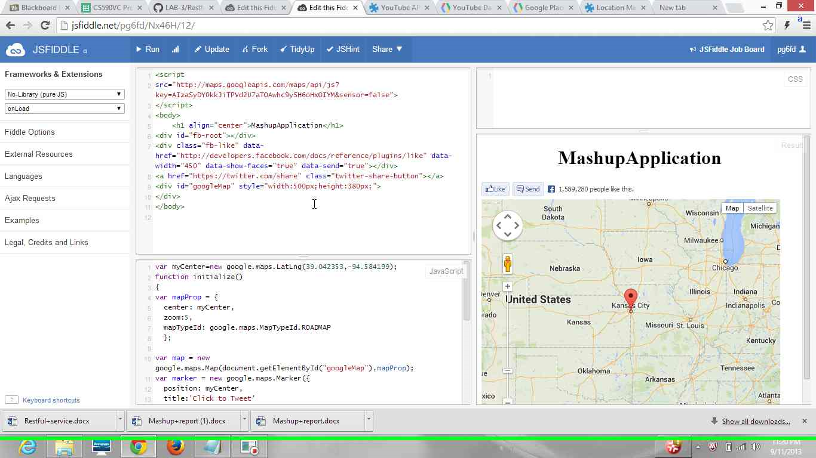

On clicking on the marker,we get tweet button. By that we can tweet directly to all followers.

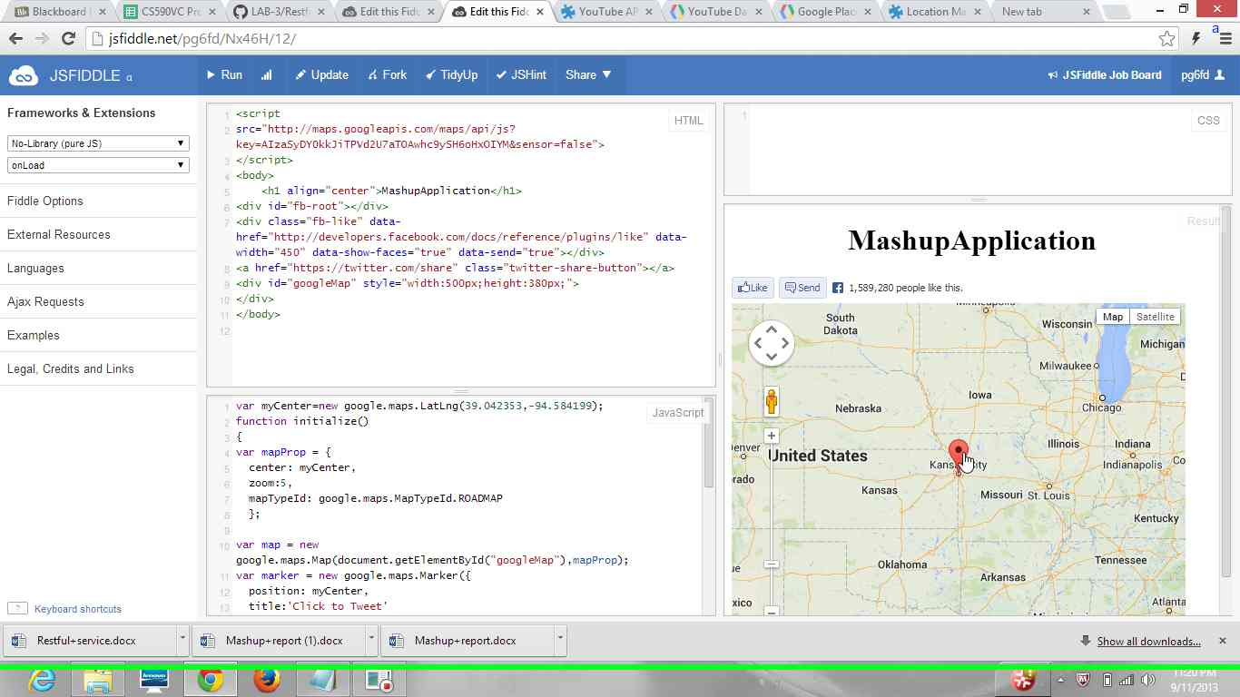

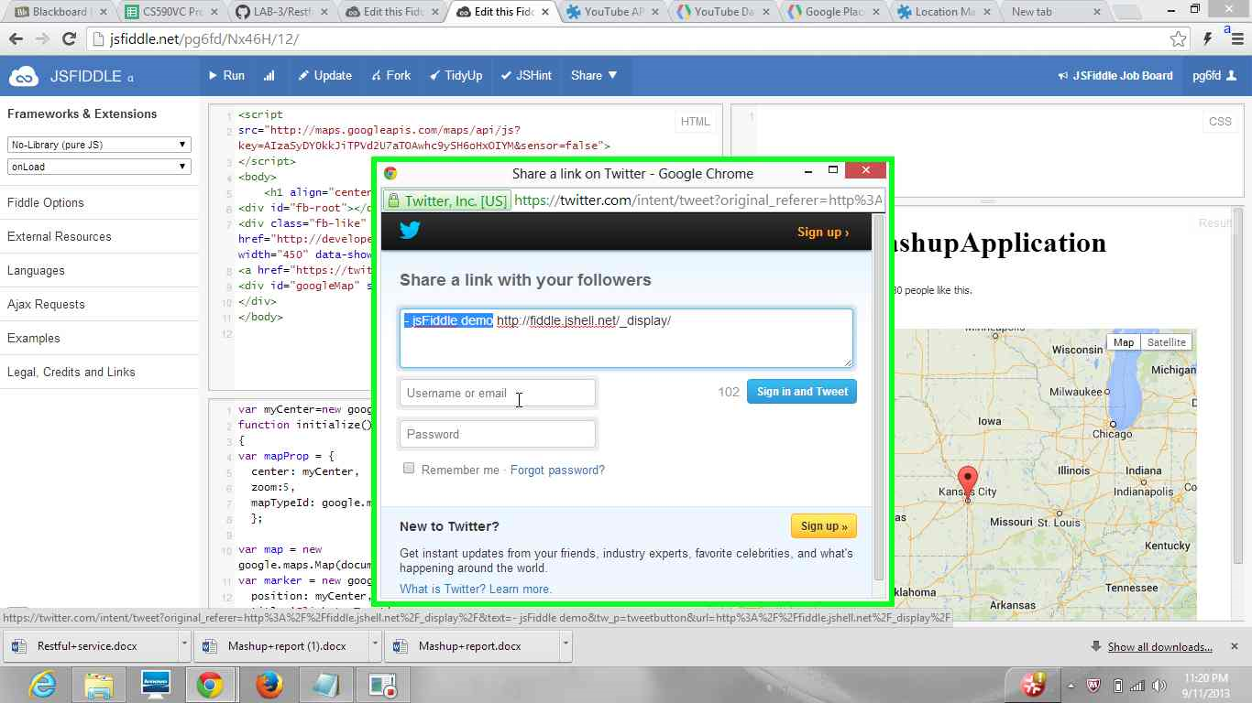

On clicking the face book like button we get the face book login page, and from that we can directly login to face book account and can directly like that page.

